**Practical 4**

**To know the size and ranges of various data types**

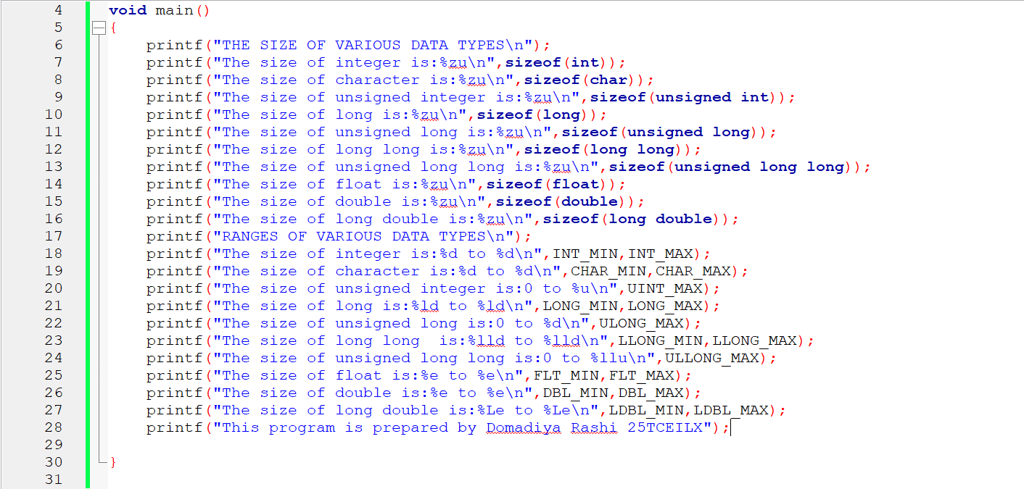

**OUTPUT:**

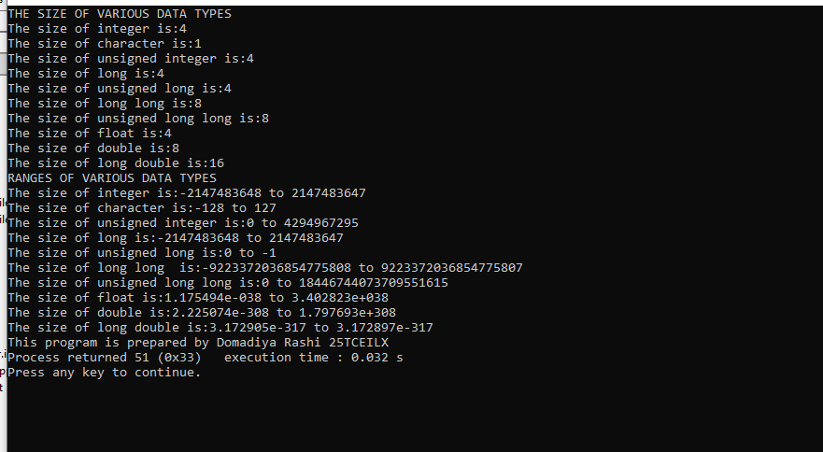

**This program is developed by DOMADIYA RASHI 25TCEILX**